The decarbonization of the airline industry from the World’s first flight by the Wright Brothers to the World’s First Sustainable Aviation Fuel Tax by Singapore
By Matthew F. Kurniawan

From the Wright Brothers’s first flight in 1903 to the modern era of Sustainable Aviation Fuel (SAF), aviation is returning to its roots of innovation to solve the climate crisis. The revolutionary SAF fuel derives from renewable waste oils and agricultural residue, offering up to 80% lower carbon cycle emissions. This transition aims to make aviation as sustainable as it was during its low-emission days, while powering the future of air travel. Leading this transition is Singapore, which announced the world’s first mandatory sustainable aviation fuel levy starting from October 1, 2026. This landmark move marks a unique, consumer-focused approach to financing the future of flight. This shift highlights a major evolution to cleaner, alternative energy for air travel. While early pioneers focused on the feasibility of flight, modern aviation is focused on the sustainability of it. The shift from the Wright Brothers’ initial gasoline to sustainable aviation fuels of today represents a crucial evolution in environmental stewardship and decarbonization of the airline industry.
The father of aviation, Sir George Cayley (1804-1853) established the fundamental principles of aerodynamics (lift, drag, and thrust) and flew the first successful manned glider in 1853. Significant advances in glider technology were made, with Otto Lilienthal and Sir George Cayley being key pioneers. Lilienthal made over 2000 controlled glides between 1891 and 1896. These innovators focused on developing stable, controllable, heavier than air aircraft.
The first ever airplane, the 1903 Wright Flyer, flown by Wilbur and Orville Wright (The Wirght Brothers) was flown over Kitty Hawk, North Carolina. The historic flight lasted twelve seconds with Orville Weight at the controls. This was the first successful powered, controlled, heavier than air airplane. This airplane featured a 12-horsepower engine and used a low octane gasoline which was gravity fed from a tank on a wing strut to a custom built four-cylinder engine. The fuel had a low octane rating, likely between 30 and 40. The early, primitive fuel air mixing systems (carburetors) and lack of cooling meant that these systems operated on the edge of failure. The Wright Brothers shop mechanic, Charlie Taylor, was the engine builder. The Wright brothers completed four flights that day, with the longest lasting 59 seconds and covering 852 feet.
As aircraft engines became more powerful, the need for higher compression ratios became critical to improving performance and fuel efficiency. The early aviation gas (Avgas) used was a 65-octane fuel. As engines became more powerful, knocking became a limiting factor. To combat this, the industry introduced Tetraethyl Lead (TEL) in the 1920s to improve octane rating, which enabled the use of high-performance piston engines required for World War II fighter planes, such as the Rolls Royce Merlin engine.
Airline fuels have evolved from early gasoline to specialized kerosene-based jet fuels (Jet A/A1) in the 1950s which was because of the shift to gas powered turbine engines which required a fuel with a higher flash point. Jet engines do not require high octane to precent pre-ignition. However, they require fuel with a high energy density and a lower freezing point. The jet engine allowed for the development of larger, more durable aircraft. The 1970s brought in wide-body aircraft (Boeing 747) which prioritized fuel efficiency, leading to the development of high-bypass turbofan engines.
Following the EPA’s ban on leaded fuel in the 1970s and 80s, aviation struggled to drop leaded fuel from piston engines, resulting in the adoption of 100LL (low lead). Testing began on alternative fuels in 2008. In that year, Virgin Atlantic conducted the first test flight using a mix of biofuel (derived from babassu oil and coconut oil) and conventional fuel in one jet engine.
Sustainable Aviation Fuel (SAF) is currently derived from renewable feedstocks, including cooking oil, animal fats, and municipal waste. It is chemically similar to conventional jet fuel and can be used without modifying engines. In March 2016 United Airlines became the first airline to use sustainable aviation fuel for routine operations at Los Angeles. World Energy (formerly AltAir Fuels) supplies the fuel to the Los Angeles hub.
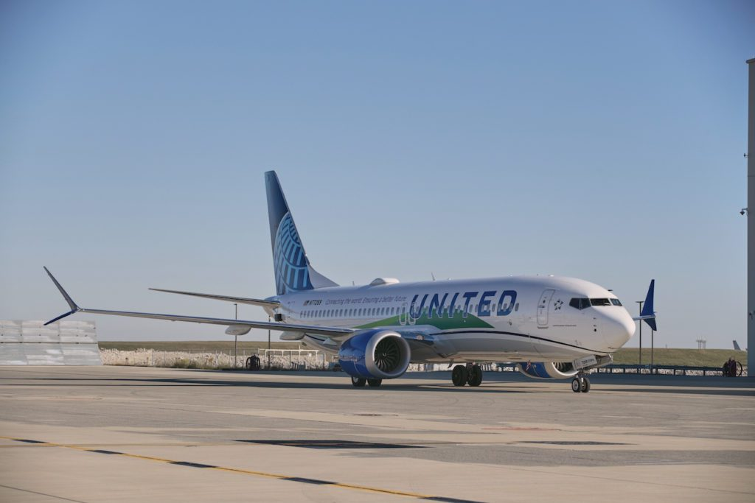
Figure X: United Boeing Max 737-8 on the tarmac of O’Hare, Dec 1. Image credit: United Airlines.
General Electric Aerospace reports that on December 1, 2021, United Airlines operated the first passenger flight using 100% sustainable aviation fuel in one of two aircraft engines on a flight from Chicago to Washington, D.C. on a Boeing 737 Max 8 with 115 passengers on board. At that time, international standards following the process developed by ASTM international permitted airlines to use a maximum of 50% SAF on commercial flights. On that flight, United Airlines operated one of the planes’ engines on 100% SAF fuel and the other on conventional jet fuel, which was about 500 gallons per engine. The SAF is interchangeable with conventional Jet A and A1 fuel and requires no modifications to engines or airframes. GE Aviation’s SAF testing included several industry-first test flights: the first commercial SAF demonstration test flight (2008), the first SAF transatlantic flight of a large freight commercial airplane (2011), the first 100% SAF military jet flight (2016) and the first use of power-to-liquid (PtL) earlier in 2021, in which renewable energy is used to split water in hydrogen and oxygen, then the resulting H2 is used with captured CO2 to synthesize liquid hydrocarbon fuel.
United has made the largest commitment of any airline in the world towards the transition to Sustainable Aviation Fuel. In Spring 2021, United launched the Eco-Skies Alliance program in which a list of 29 corporate partners and counting have collectively contributed towards the purchase of approximately 5.7 million gallons of SAF in 2021. This eliminates approximately 53,000 metric tons of GHG emissions, or enough to fly passengers over 372 million miles.
SAF production is growing with US production doubling between December 2024 and February 2025. SAF can reduce lifecycle CO2 emissions by up to 80%. SAF produces fewer chemical pollutants and, due to lower aromatic content, reduces contrail formation, a major contributor to radiative forcing (atmospheric warming). The aviation industry faces increasing pressure as air traffic grows. Current efforts focus on scaling up, with 100% renewable fuel on the horizon, alongside research into hydrogen and electric propulsion. Large-scale implementation could contribute to 64% total emissions savings by 2050. The challenges of implementing sustainable aviation fuel include the lack of production capacity as current production only meets 1% of the global jet fuel demand. High production costs (USD 2500 per metric tonne (1000kg) for SAV vs USD 734 for conventional fuel) limit voluntary uptake by airlines. A technology limitation of SAF is that it requires requires significant energy to produce, which may affect scalability.
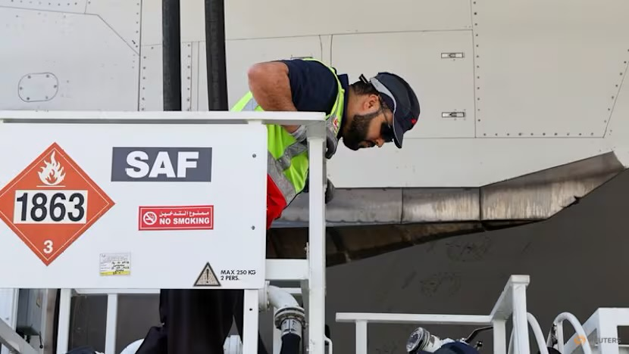
Figure X: Sustainable Aviation Fuel levy. File photo: Reuters.
To scale SAF, governments are implementing policies to incentivize production and mandate usage, bridging the price gap. One such policy is the implementation of the world’s first ever sustainable aviation fuel levy for flights that are departing from Singapore Changi Airport from October 1, 2026 and for tickets sold from April 1, 2026, with a surcharge from S$1 to S$41.60 per ticket depending on travel destination and airline class in four bands. This is to fund the procurement of SAF, aiming for a 1% SAF blend at Changi and Seletar Airports in 2026, increasing to 3-5% in 2030. At that point, levy adjustments will be made then. This fee applies to all departing passengers but excludes those in transit. The airline must collect the levy and display it as a separate line item on air tickets sold and air cargo contracts. Training flights and those for charitable or humanitarian purposes are exempt from the levy. Funds will be managed by a central agency, SAF co. to aggregate demand and secure fuel, which is currently 3-5 times more expensive than conventional fuel. This initiative aligns with Singapore’s commitment to net-zero carbon emissions by 2050 (Guang-Xi 2025).
Sustainable Aviation Fuel Levy | Economy/premium economy | Business/First class | Cargo levy per kg
Band 1: Southeast Asia | S$1.00 | S$4.00 | S$1
Band 2: Northeast Asia Papua New Guinea South Asia and Australia | S$2.80 | S$11.20 | S$4
Band 3: Europe Middle East Pacific Islands New Zealand, Central and West Asia | S$6.40 | S$25.60 | S$9
Band 4: The Americas | S$10.40 | S$41.60 | S$15

The progression from the Wright Brothers’s innovation to the use of Sustainable Aviation Fuel and Singapore’s world first sustainable aviation fuel levy proves that the future of flight requires blending the pioneering spirit of early aviation with the modern environmental science. While SAF is a technology that can be used in conventional jet engines, its success depends heavily on such policy-driven funding to ensure scalability. As Singapore acts as a catalyst on this, the transition to cleaner, more sustainable aviation represents the move from concept to reality while bridging the gap between historical achievement and environmental necessity.

References
GE Reports (2021, December) United To Fly World’s First Passenger Flight On 100% Sustainable Aviation Fuel Supplying One Of Its Engines | GE Aerospace News. Geaerospace.com. https://www.geaerospace.com/news/articles/product-sustainability-technology/united-fly-worlds-first-passenger-flight-100-sustainable
Guang-Xi, Justin Ong (2025). Air travellers departing Singapore to pay sustainable aviation fuel levy of S$1 to S$41.60 per ticket. CNA. https://www.channelnewsasia.com/singapore/sustainable-aviation-fuel-levy-flights-depart-changi-seletar-airport-caas-5457376

‌This report was created in part with assistance from Google Gemini for drafting content related to the first airplane and sustainable aviation fuel, the introduction, and the conclusion section. This content was reviewed and edited by the author.

